How to install Minikube on CentOS 7 and 8

How to install Minikube on CentOS 7 and 8

In this tutorial, we will learn How to install Minikube on CentOS 7 and 8. Minikube is free software that lets you set up a small Kubernetes cluster with a single computer. The software starts up a virtual machine and runs a [Kubernetes cluster](https://kubernetes.io/docs/concepts/overview/)inside of it. This lets you test directly in a Kubernetes environment.

Prerequisites

* A normal user with SUDO privileges or Super user
* Yum repositories configured to install packages in your [CentOS server](https://utho.com/docs/tutorial/microhost-product-details/).

Steps to install Minikube on Centos

Step 1: Update your machine

**yum -y update**

Step 2: Install EPEL repositories using below command.

**yum -y install epel-release**

Step 3: Install libvirt packages, dependencies to run Minikube

**yum -y install libvirt qemu-kvm virt-install virt-top libguestfs-tools bridge-utils**

Step 4: Now run, enable and check the status of libvirt daemon to ensure it is running and installed successfully.

**systemctl enable --now libvirtd**

**systemctl status libvirtd**

Step 5: Now, add your any normal user to libvirt group by using usermod command.

**useradd kittu**

**usermod -aG libvirt <normal-username>**

**usermod -aG libvirt kittu # my normal user**

Step 6: Now, append the below mentioned details to the below file.

**vi /etc/libvirt/libvirtd.conf**

Append contend to above file::

unix_sock_group = "libvirt"

unix_sock_rw_perms = "0770"

Step 7: Restart the libvirtd daemon/ service to reflcet the changes.

**systemctl restart libvirtd.service**

Download Minikube binary

Step 8: Download and install the minikube binary using the curl and install command as shown below.

**curl -LO https://storage.googleapis.com/minikube/releases/latest/minikube-linux-amd64**

**sudo install minikube-linux-amd64 /usr/local/bin/minikube**

Step 9: Check the version installed of your minikube.

**minikube version**

Minikube install on CentOS 

Minikube install on CentOS

Download Kubectl binary and installed it

Step 10: Download the latest kubectl binary using the below command

**curl -LO https://storage.googleapis.com/kubernetes-release/release/`curl -s https://storage.googleapis.com/kubernetes-release/release/stable.txt`/bin/linux/amd64/kubectl**

Step 11: Now, make the binary executable, so the it can be run

**chmod +x kubectl**

Step 12: Move the binary to /usr/loca/bin directory so that it can be run from anywhere of your machine.

**mv kubectl /usr/local/bin**

Step 13: Check the version installed on your centos machine

**kubectl version --client -o json**

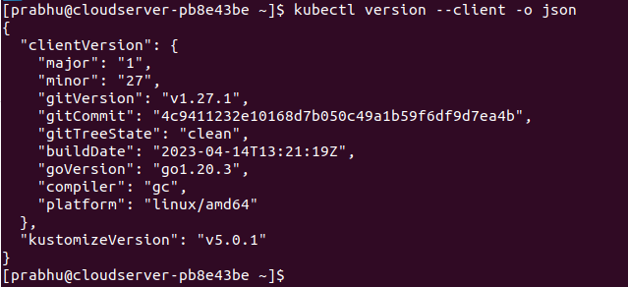

Version of installed kubectl

Install Docker container

Step 14: Now, without, docker environment, you cannot run minikube. Therefore, run the below command to add the repolist to your machine to install Docker.

**yum install -y yum-utils**

**yum-config-manager --add-repo https://download.docker.com/linux/centos/docker-ce.repo**

Step 15: Install the docker related dependencies to run your minikube.

**yum install –y docker-ce docker-ce-cli containerd.io docker-buildx-plugin docker-compose-plugin**

Step 16: Now, run the below command to enable and start the docker service instantly

**systemctl enable --now docker**

Step 17: Check the docker running version.

**docker version**

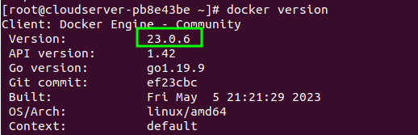

Docker installed on Centos

Step 18: Now, add your normal user( user which is added to libvirt group in earlier step) to the docker group as well.

**usermod -aG docker kittu**

Step 19: Now, switch to that user and run the minikube with driver docker as a default driver.

**su - kittu**

**minikube start --driver=docker**

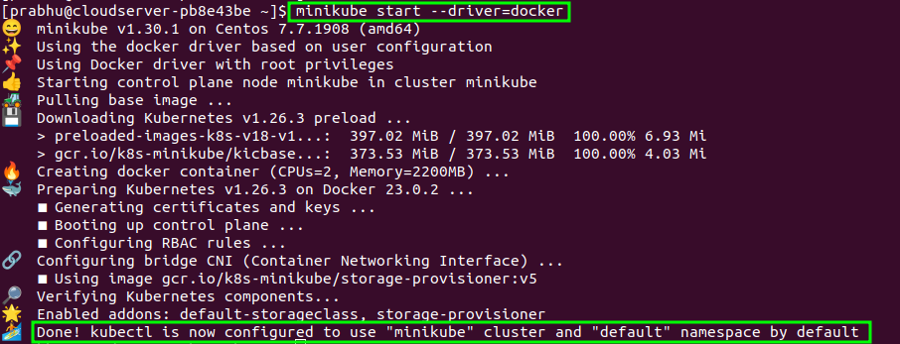

**how to deploy httpd web server in minikube on centos 7**

To deploy the Apache HTTP server (httpd) in Minikube on CentOS 7, you need to create a Kubernetes Deployment manifest that describes the desired state of the application. Here's a step-by-step guide to deploying httpd:

1. Start Minikube (if not already running):

**minikube start**

1. Create a file named **httpdeploy.yml** and paste the following content into it:

**apiVersion: apps/v1**

**kind: Deployment**

**metadata:**

**name: httpdeploy**

**spec:**

**replicas: 1**

**selector:**

**matchLabels:**

**app: httpd**

**template:**

**metadata:**

**labels:**

**app: httpd**

**spec:**

**containers:**

**- name: httpd**

**image: httpd:latest**

**ports:**

**- containerPort: 80**

This YAML manifest defines a Deployment with a single replica running an httpd container, exposing port 80.

1. Apply the Deployment to Minikube:

**kubectl apply -f httpdeploy.yml**

1. Check the status of the Deployment:

**kubectl get deployments**

1. Expose the Deployment as a service:

**kubectl expose deployment httpdeploy --type=NodePort --port=80**

1. Get the NodePort assigned to the service:

**kubectl get service httpdeploy**

Look for the "80:<NodePort>/TCP" entry. The NodePort value will be dynamically assigned.

1. Access the httpd web server:

To access the httpd web server running in Minikube, you need to find the IP address of the Minikube cluster:

**minikube ip**

Now, open a web browser and enter the following address:

**http://<minikube-ip>:<NodePort>**

Replace **<minikube-ip>** with the output of **minikube ip**, and **<NodePort>** with the value obtained from

**kubectl get service httpdeploy**

You should see the default Apache HTTP server page indicating that httpd has been successfully deployed in Minikube.

Please note that this example uses the latest **httpd** image, which might not be the best choice for production deployments. In production, you should use a specific version of the httpd image and consider other configuration options based on your requirements.